Mini Project Assessment
Business Case
You are working as a Data Engineer for QuickCart, a rapidly growing e-commerce and logistics platform.
The company currently faces:
- Slow dashboard performance
- Duplicate customer records
- Delayed reporting
- Pipeline failures
- High storage costs
- Difficulty processing clickstream logs
- Poor query performance on large datasets
The organization wants to build a scalable modern data platform using: Python, SQL, Pandas, , Airflow and modern ETL/ELT architecture.

Expected Deliverables
Students must submit:
1.SQL scripts (.sql)
2. Python notebooks/scripts (.py /.ipynb)
3. Airflow DAG (files/scripts)
4.Architecture diagram (word file/paint/onenote etc.)

DATASETS PROVIDED
1. customers.csv
customer_id
customer_name
email
city
signup_date
2. orders.csv
order_id
customer_id
product_id
order_date
quantity
unit_price
payment_status
3. products.csv
product_id
product_name
category
supplier_id
cost_price
selling_price
4. clickstream.csv
event_id
customer_id
event_type
page_url
event_timestamp
device_type
Dataset : given on the drive in a zipped folder

Section A - Data Engineering Theory
Q1. OLTP vs OLAP Architecture
The company currently stores transactional and analytical workloads in the same SQL database.
Tasks
1. Explain why this creates performance issues.
The company currently stores transactional and analytical workloads in the same SQL database. Transactional and analytical workloads should be stored separately as running both on one database makes them compete for resources, slowing everything down.
2. Compare OLTP and OLAP workloads.

oltp | olap
Day to day operations | Data analysis and reporting
Small transactions | Few large queries
Current data | Historical data
Fast writes | Fast reads

3. Suggest an improved architecture.
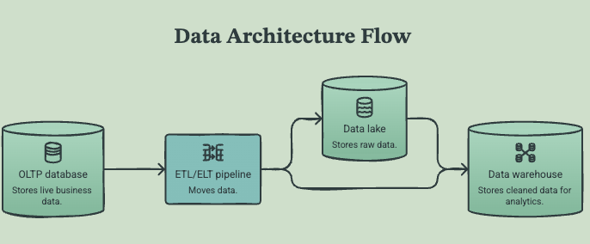
4. Explain where:
-PostgreSQL /SQLServer/MySql > OLTP for daily transactions
-Data warehouse > reporting, business intelligence, analytics and dashboards
-Data lake > stores raw data
should be used.
Q2. ACID vs BASE in Distributed Systems
QuickCart wants to store clickstream events from millions of users. Tasks
1. Explain why BASE systems are preferred for clickstream systems.
Because clickstream data is large and is generated very fast. Therefore, BASE systems prioritize availability.
2. Which workloads require ACID compliance?
- customer account updates
- Orders
- Payments
- Inventory
- Bank transactions
3. Give examples where eventual consistency is acceptable.
- Search results
- Click tracking in websites
- Social media likes
Q3. Storage Formats & Querying
Tasks
1. Compare:
-CSV > rows and columns easy to read for non technical departments in companies
-JSON > stores data as key value pairs.
-Avro > row based format and useful for data streaming
-Parquet > columnar base format. Useful for analytics and large queries.

2. Why do analytical systems prefer columnar storage?
Columnar storage makes queries efficient and they use less storage.

3. Explain avro vs json format.
Avro has a defined schema. It is smaller and faster.
JSON does not have a schema and it is larger and slower.
Avro is good for streaming and json for apis and simple data exchange
4. Explain compression benefits in Parquet.
Reduces storage costs and makes queries faster so this is ideal for analytics.

Q4. Partitioning, Indexing
Tasks
1. Design a partitioning strategy for:
-orders table : order_year/orders_month
-clickstream data: clicks_year/clicks_month/clicks_day
2. Suggest indexing strategy for:
-customer lookups:
creating an index on customer id

-order filtering: by customer id
-joins: from customers join orders on c.customer_id = o.customer_id
3. Explain when indexes negatively affect performance.
Indexes require extra storage
Section B - SQL Engineering

DATASETS PROVIDED
1. customers.csv
customer_id
customer_name
email
city
signup_date
2. orders.csv
order_id
customer_id
product_id
order_date
quantity
unit_price
payment_status
3. products.csv
product_id
product_name
category
supplier_id
cost_price
selling_price
4. clickstream.csv
event_id
customer_id
event_type
page_url
event_timestamp
device_type
Q1. Intermediate SQL Queries
Write SQL queries to:
1. Find top 10 customers by revenue.
2. Find month-over-month sales growth.
3. Find customers who ordered in consecutive months. 4. Find products never ordered.
5. Find revenue contribution percentage by category.
Q2. Advanced SQL
Tasks
1. Rank customers based on total revenue.
2. Find running total sales by month.
3. Find the highest selling product per category.
4. Find 7-day rolling average sales.
Q3. SQL Optimization Scenario
The following query takes 18 minutes:
SELECT c.customer_name,
SUM(o.quantity * o.unit_price)
FROM orders o
JOIN customers c
ON o.customer_id = c.customer_id
WHERE order_date >= '2025-01-01'
GROUP BY c.customer_name;
Tasks
1. Identify possible bottlenecks.
This is a full table scan because of the filter WHERE order_date >= '2025-01-01' therefore, slow join if customer_id is not indexed
2. Suggest indexes.
CREATE INDEX idx_orders_date
ON orders(order_date);
3. Explain execution plan analysis.
'-> Table scan on <temporary> (actual time=2.15..2.17 rows=100 loops=1)\n -> Aggregate using temporary table (actual time=2.15..2.15 rows=100 loops=1)\n -> Nested loop inner join (cost=223 rows=491) (actual time=0.0703..1.39 rows=491 loops=1)\n -> Filter: ((o.order_date >= DATE\'2025-01-01\') and (o.customer_id is not null)) (cost=51 rows=491) (actual time=0.0489..0.338 rows=491 loops=1)\n -> Table scan on o (cost=51 rows=500) (actual time=0.0468..0.259 rows=500 loops=1)\n -> Single-row index lookup on c using PRIMARY (customer_id = o.customer_id) (cost=0.25 rows=1) (actual time=0.00183..0.00188 rows=1 loops=491)\n'
Table scans ALL indicate missing indexes
Rows scanned
actual time or execution time
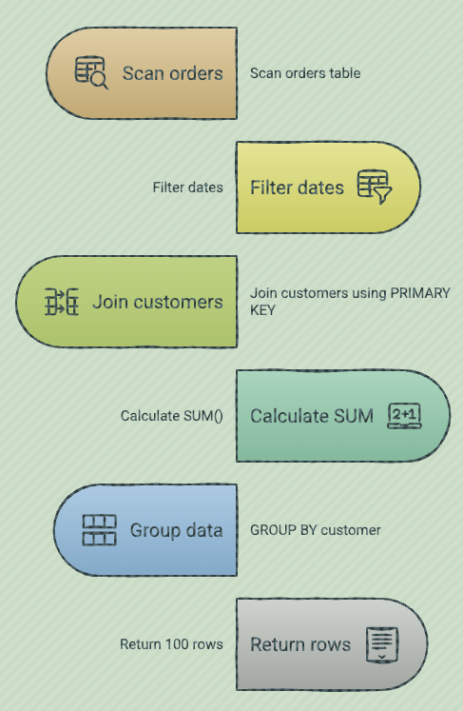

4. Suggest partitioning improvements.
Partition by date (year/month
5. Explain materialized views usefulness.
Materialized views are useful for reports and dashboards as it improves efficiency and reduces the use of joins.
Q4. Database Design
Design schema for:
1. Shipment tracking
TABLE shipments
Columns: shipment_id INT PRIMARY KEY, customer_id INT FK, shipment_date DATE, status VARCHAR(100), tracking_number VARCHAR(200) UNIQUE
Indexing recommendation:
CREATE INDEX idx_shipments_customer
ON shipments(customer_id)
2. Product inventory
TABLE product
Columns: product_id INT PRIMARY KEY, product name VARCHAR(100), category VARCHAR(150), cost_price DECIMAL(10,2), selling_price DECIMAL(10,2), inventory_id INT FOREIGN KEY
Indexing recommendation:
CREATE INDEX idx_product_product_id
ON product(product_id)

TABLE product_inventory
Columns: inventory_id INT PRIMARY KEY, product_id INT FOREIGN KEY, quantity

Indexing recommendation:
CREATE INDEX idx_inventory_product_id
ON product_inventory (product_id)

3. Customer support tickets
TABLE support_tickets
Columns: ticket_id INT PRIMARY KEY, customer_id INT FOREIGN KEY, subject VARCHAR(200), description TEXT, status VARCHAR(50), created_date DATE,
Indexing recommendation:
CREATE INDEX idx_support_tickets
ON support_tickets(customer-id)
Requirements:
• normalized design
• primary keys
• foreign keys
• indexing recommendations
Section C - Python + Pandas Engineering
Q1. Data Ingestion Pipeline
Using Python and Pandas:
Tasks
1. Read all datasets.
2. Validate schema consistency.
3. Detect duplicate customers.

4. Identify invalid records.
Q2. Data Cleaning & Transformation
Tasks
1. Standardize city names. (if any)
2. Convert timestamps correctly. (if any)
3. Handle missing values. (if any)
4. Remove corrupted rows.
Q3. Clickstream Analytics
Using clickstream data:
Tasks
1. Find the most visited pages.
2. Calculate session counts.
3. Find bounce rate.
4. Find mobile vs desktop traffic percentage.
Q4. Export Optimization
Tasks
1. Export analytical dataset into:
o CSV
o Parquet
2. Compare storage sizes.
3. Compare read performance.

Section D - ETL/ELT + Airflow

Q1. ETL vs ELT Architecture
Tasks
1. Compare ETL vs ELT.
ETL: data is extracted from the source systems then is transformed before loading it in the warehouse for analysis.
ELT data is extracted and is loaded directly in a warehouse or data lake and then transformed within the storage system.
2. Explain why cloud warehouses prefer ELT.
Cloud data warehouses are designed to manage large amounts of data. In addition to that, because cloud data warehouses provide cost efficiency and flexibility.
3. Design modern ELT pipeline for QuickCart.
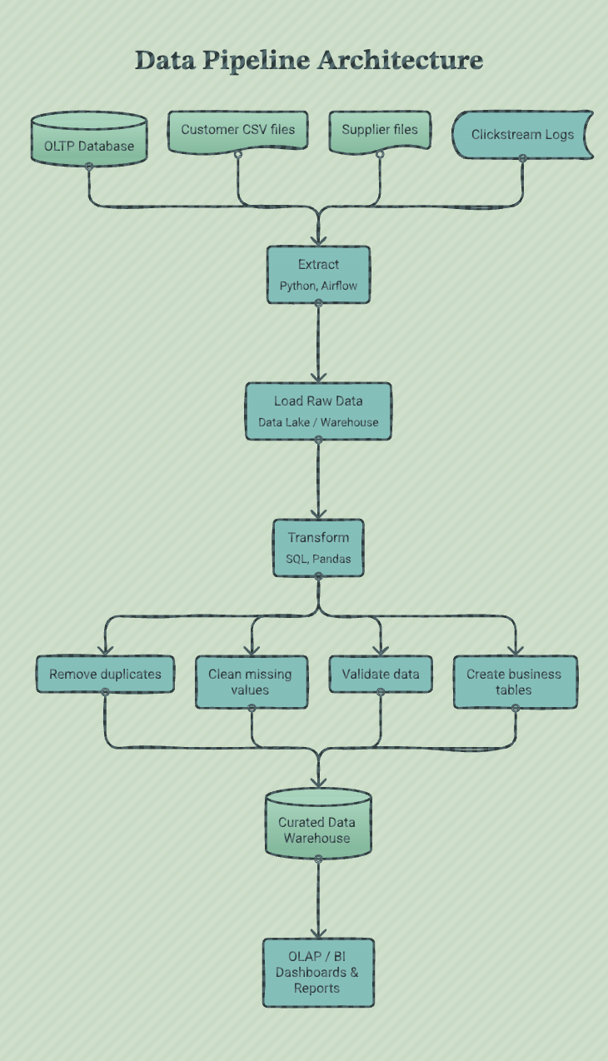

Q2. Airflow DAG Development
Create an Airflow DAG that:
Requirements
1. Runs daily at 2 AM
2. Extracts CSV files
3. Performs validation
4. Loads raw data into staging tables 5. Triggers transformation step
6. Sends failure email alerts
DAG must include:
• retries
• retry delays
• task dependencies
• logging
• scheduling
• sensors
Q3. Data Warehouse Modeling
Tasks
1. Design star schema.
2. Identify:
fact tables
dimension tables

dim_customer
|
|
dim_product ------ fact_orders ------ dim_date
|
|
sales metrics
quantity
unit_price
total_sales

dim_customer
|
|
dim_product ---- fact_clickstream ---- dim_date
|
|
customer behaviour

Type | Table Name | Source | Purpose | Main Columns
Fact | fact_orders | orders.csv | Stores sales transactions and business metrics | order_id, customer_key, product_key, date_key, quantity, unit_price, total_sales, payment_status
Fact | fact_clickstream | clickstream.csv | Stores customer behaviour events (clicks, views, actions) | event_id, customer_key, product_key, date_key, event_type, page_url, device_type, event_count
Dimension | dim_customer | customers.csv | Stores customer information used for analysis | customer_key, customer_id, customer_name, email, city, signup_date
Dimension | dim_product | products.csv | Stores product information used for analysis | product_key, product_id, product_name, category, supplier_id
Dimension | dim_date | Created in warehouse | Stores date information for time analysis | date_key, full_date, day, month, quarter, year

Section E - Performance Engineering Case Study
Scenario
QuickCart processes:
• 50 million clickstream events/day • 5 million orders/day
Problems:
• SQL queries are slow
• Pipelines fail frequently
• Dashboard refresh takes 3 hours • Storage cost is increasing
Tasks
Part 1 - Architecture Design
Design scalable architecture using:
• database
• data lake
• warehouse
• orchestration
• transformation layer

LAYER | PURPOSE | TECHNOLOGY EXAMPLES | RESPONSIBILITIES | QUICKCART USAGE
operational database (oltp) | store real-time business transactions | postgresql, mysql, cloud sql | handles fast inserts, updates, and transactions | stores customers, orders, payments, inventory
data lake | store large volumes of raw and historical data | amazon s3, google cloud storage, azure data lake | stores structured and unstructured data at low cost | stores raw clickstream events (50m/day), order files, logs
data warehouse (olap) | store optimized data for analytics and reporting | bigquery, snowflake, amazon redshift | supports complex queries, dashboards, and business analysis | stores fact tables and dimensions such as fact_orders, fact_clickstream, dim_customer, dim_product
orchestration layer | manage and schedule data workflows | apache airflow | schedules pipelines, manages dependencies, retries failures, monitors jobs | runs daily etl/elt workflows and triggers data loads
transformation layer | clean and transform raw data into analytical datasets | dbt, apache spark | performs data cleaning, joins, calculations, and business logic | creates analytics tables, calculates metrics like revenue and customer behaviour
data storage format | optimize storage and query performance | parquet, orc | provides compression and column-based storage | stores processed clickstream and order data efficiently
bi / analytics layer | provide insights to business users | looker, power bi, tableau | creates dashboards and reports | displays sales performance, customer trends, and clickstream analytics

Part 2 - Optimization
Explain:
1. Partitioning strategy
2. Indexing strategy
3. Compression strategy
4. Query optimization
5. Incremental loading
6. Columnar storage benefits

optimization technique | explanation | implementation example | benefits
1. partitioning strategy | splits large tables into smaller sections based on a column, reducing the amount of data scanned during queries. | partition fact_clickstream by event_date and fact_orders by order_date. example: year=2026/month=07/day=26 | faster queries, lower processing costs, improved dashboard performance
2. indexing strategy | creates indexes on frequently searched or joined columns to speed up data retrieval. | create indexes on customer_id, product_id, and order_date in the orders table. example: create index idx_orders_customer on orders(customer_id); | faster filtering, faster joins, improved query performance
3. compression strategy | reduces storage size by compressing data files, especially large analytical datasets. | store processed data using compressed formats such as parquet or orc instead of csv. | reduces storage costs, improves data transfer speed, faster queries
4. query optimization | improves sql performance by reducing unnecessary processing. | avoid select *, select only required columns, filter data before joins, use partition filters, create summary tables. | faster sql execution, reduced warehouse workload, quicker dashboards
5. incremental loading | loads only new or changed records instead of processing the entire dataset every time. | load only orders where updated_at > last_load_time or use change data capture (cdc). | faster pipelines, lower compute costs, reduces processing time
6. columnar storage benefits | stores data by columns instead of rows, making analytical queries faster because only required columns are read. | store warehouse tables using parquet or orc format. example: querying sum(quantity) reads only the quantity column. | faster analytics queries, better compression, improved warehouse performance

Part 3 - Reliability
Explain:
1. Retry handling
2. Failure alerts
3. Data quality validation

reliability technique | explanation | implementation example | benefits
1. retry handling | automatically retries failed tasks caused by temporary issues such as network problems or unavailable services. | airflow configuration: retries=3, retry_delay=timedelta(minutes=5) | reduces pipeline failures, improves reliability, handles temporary errors automatically
2. failure alerts | sends notifications when pipelines fail so engineers can investigate quickly. | airflow email alerts, slack notifications, pagerduty alerts when tasks fail. | faster incident response, reduced downtime, better monitoring
3. data quality validation | checks that data is complete, accurate, and follows business rules before entering production systems. | validate missing values, duplicates, incorrect data types, invalid values (e.g., negative quantities). tools: dbt tests, great expectations. | prevents bad data reaching dashboards, improves trust in analytics

